AI-Driven Virtual Healthcare Assistant for Automated Medicine Dispensing

**ABSTRACT:** In recent years, there has been a sharp increase in demand for virtual healthcare systems, especially in underprivileged and rural areas where timely access to medical care is frequently limited. In order to address these demands, this project presents an AI-powered virtual healthcare assistant that facilitates remote health consultations and provides timely medical responses. The system gives users an easy way to share their symptoms, which are then evaluated to recommend appropriate drugs or therapies. This virtual assistant seeks to close the healthcare gap by providing quick, effective, and accessible medical services through the integration of cutting-edge AI and automation. By doing this, it considerably lessens reliance on conventional healthcare facilities and makes necessary medical supplies accessible from a distance. This technology aids in the creation of virtual, scalable healthcare solutions that guarantee ongoing medical assistance, especially in areas with inadequate infrastructure. The virtual assistant offers a creative solution to contemporary healthcare issues by promoting healthcare accessibility, affordability, and scalability through improved symptom analysis and automated delivery methods.

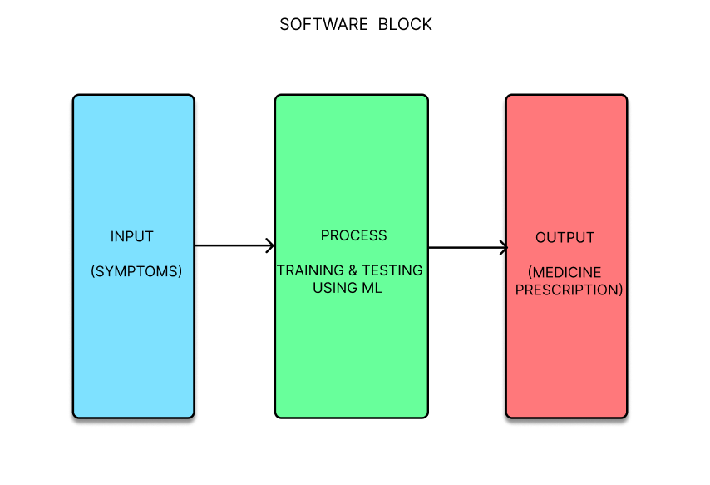**Keywords:** Virtual healthcare, AI healthcare assistant, remote health consultations, accessible medical services, healthcare automation and symptom analysis.

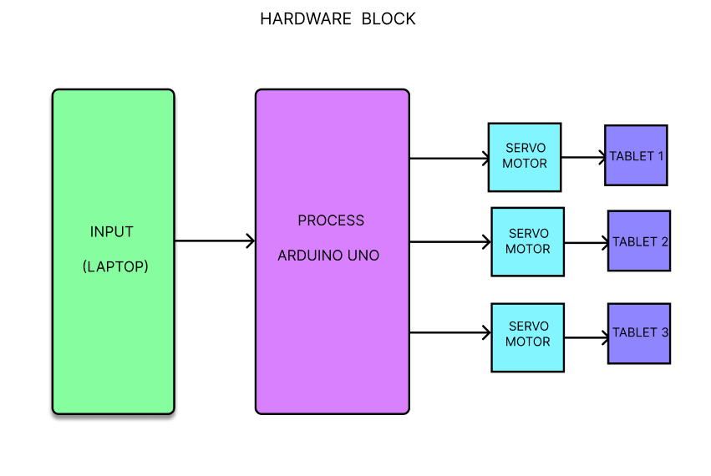

**WORKING PRINCIPLE:**

* The user enters symptoms and health concerns through an intuitive chat interface, powered by a Python program using AI and machine learning on a laptop. Through text-based interaction, the system collects symptom data, which is organized and prepared for analysis by machine learning models. These models continuously learn from a vast dataset of medical conditions, allowing the system to accurately map user symptoms to likely diseases.
* Once symptoms are entered, pre-trained machine learning models in the Python application analyse the input to identify relevant patterns between symptoms and conditions. Trained on extensive symptom-disease data, the model improves its accuracy with regular testing on fresh data. Based on the processed symptoms, the AI determines the most suitable treatment or medication.
* After identifying the necessary treatment, the AI sends the medication information to an Arduino UNO via serial communication. The Arduino interprets these instructions and activates specific motors connected to a dispensing unit, which functions like a vending machine. The motors precisely dispense the appropriate medication, ensuring accurate dosage based on the AI’s analysis.

**EXISTING SYSTEMS:**

Online pharmacies and in-person pharmacy visits are the two primary methods currently in use for receiving medications, each offering unique benefits and drawbacks. For many, picking up prescription medications or purchasing over-the-counter drugs in person at a local pharmacy remains the most common approach. This method enables direct communication with pharmacists, who can provide essential guidance on proper medication use, possible side effects, and general health considerations. In-person pharmacy visits allow patients to receive personalized advice, address immediate concerns, and ensure they understand their treatment. However, accessibility can present significant challenges. Access to necessary medications may be delayed, especially for individuals living in rural or remote areas, who may have limited pharmacy locations or restricted operating hours. Additionally, arranging for additional assistance to visit a pharmacy can be challenging for those with limited transportation options, mobility issues, or chronic health conditions. Online pharmacies have emerged as a convenient alternative, allowing patients to order prescription and over-the-counter medications online and have them delivered directly to their homes. This option is particularly advantageous for elderly or homebound individuals, as it eliminates the need for physical travel and reduces exposure to potential health risks in crowded spaces. While online pharmacies offer convenience, they also come with certain disadvantages, such as potential delivery delays and concerns about medication authenticity and quality control. These factors underscore the need for complementary or alternative approaches that provide quick, reliable, and safe access to medications, especially for underserved communities or individuals requiring immediate care.

**Disadvantages:**

* Limited accessibility due to pharmacy location and operating hours, especially in rural areas.
* Delivery delays with online pharmacies, which may not meet urgent medication needs.
* Risk of counterfeit or substandard drugs from unverified online sources.
* Lack of immediate pharmacist interaction with online orders, impacting guidance on medication use.

**PROPOSED SYSTEMS:**

This proposed system uses an easy-to-use chat interface, the suggested system presents a highly accessible, real-time virtual healthcare assistant that provides individualized, data-driven health support. This user-friendly solution, which is based on a Python-based platform driven by sophisticated machine learning algorithms, enables people to directly enter their symptoms and health concerns, avoiding the need for in-person consultations or constant internet connectivity—two common drawbacks of traditional telemedicine services. The technology is perfect for people who might not have fast access to traditional medical resources since it effectively collects and organizes symptom data, giving users immediate access to crucial healthcare insights. The platform's ability to correctly assess a wide variety of symptoms and link them to possible medical disorders is supported by strong machine learning models that have been trained on large datasets of symptoms and illnesses. A highly responsive healthcare experience is also achieved as the system continuously learns and improves from new data inputs, increasing its accuracy and steadily enhancing the relevance of its pill dispensing suggestions over time. In addition to sophisticated symptom analysis, the device has a special automated medication distribution function. When the system determines a course of treatment, it transmits detailed commands to an Arduino UNO microcontroller, which initiates an automated medicine dispensing system. Users can obtain prescription drugs nearly immediately thanks to this automation, which expedites the medicine purchase process. Accurate dosage management is ensured by motorized trays, which reduce human mistake and guarantee a dependable, effective drug delivery. This thorough integration offers a scalable and sustainable solution that provides ongoing access to vital medical help, bridging significant healthcare gaps in neglected and distant places.

**Advantages**:

* Immediate access to personalized healthcare support without in-person visits.
* Enhanced medicine prescription accuracy through machine learning models trained on extensive symptom datasets

.

* Automated medication dispensing feature for rapid, precise, and reliable medication access.
* Increased healthcare accessibility for remote and underserved areas.